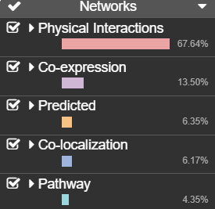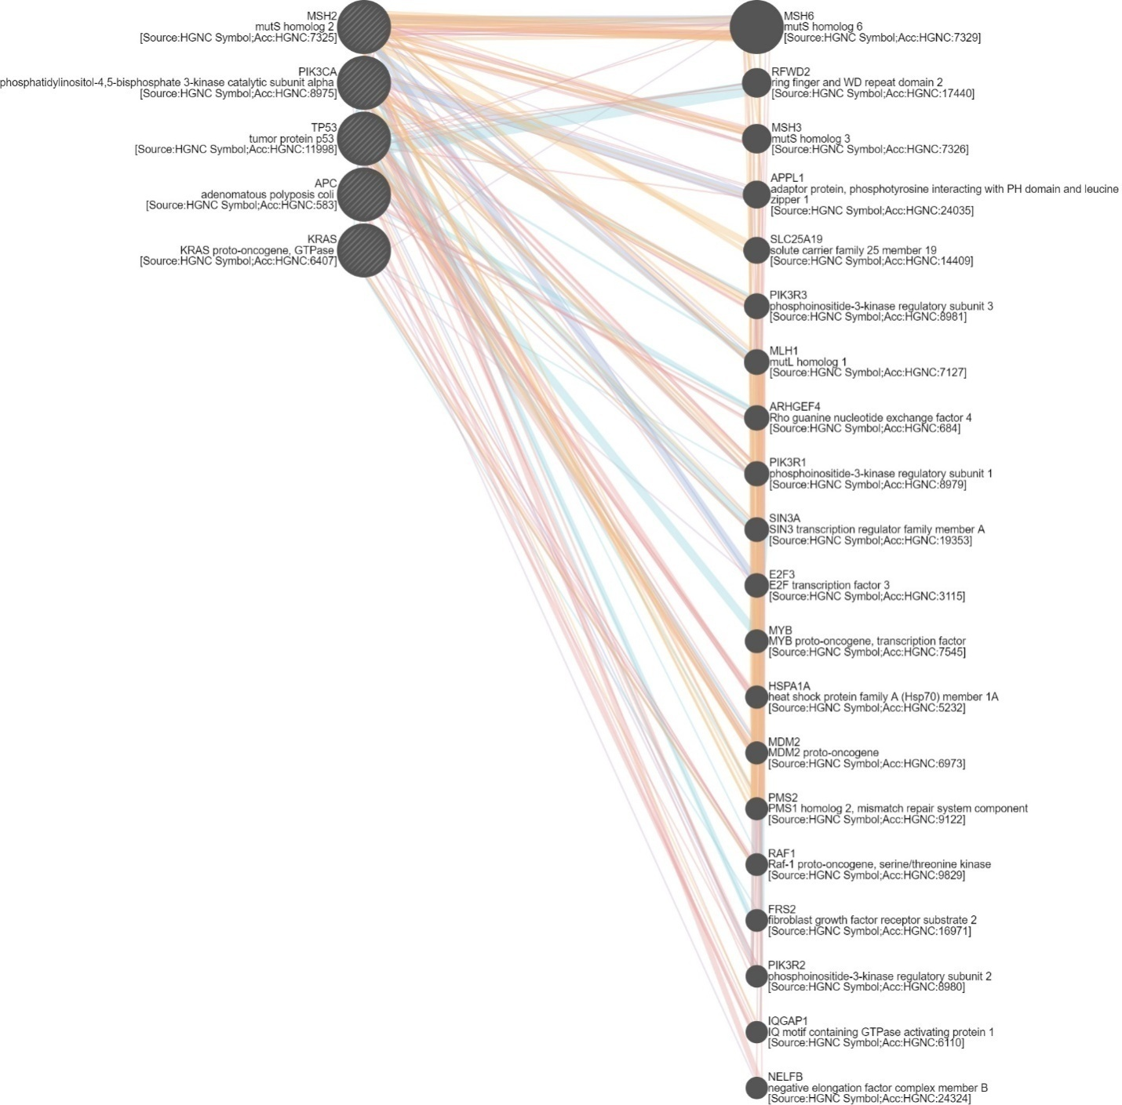

**Figure S1.1. Gene networking of Gastric and Colon Cancer genes**