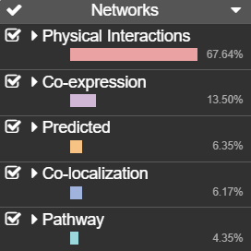

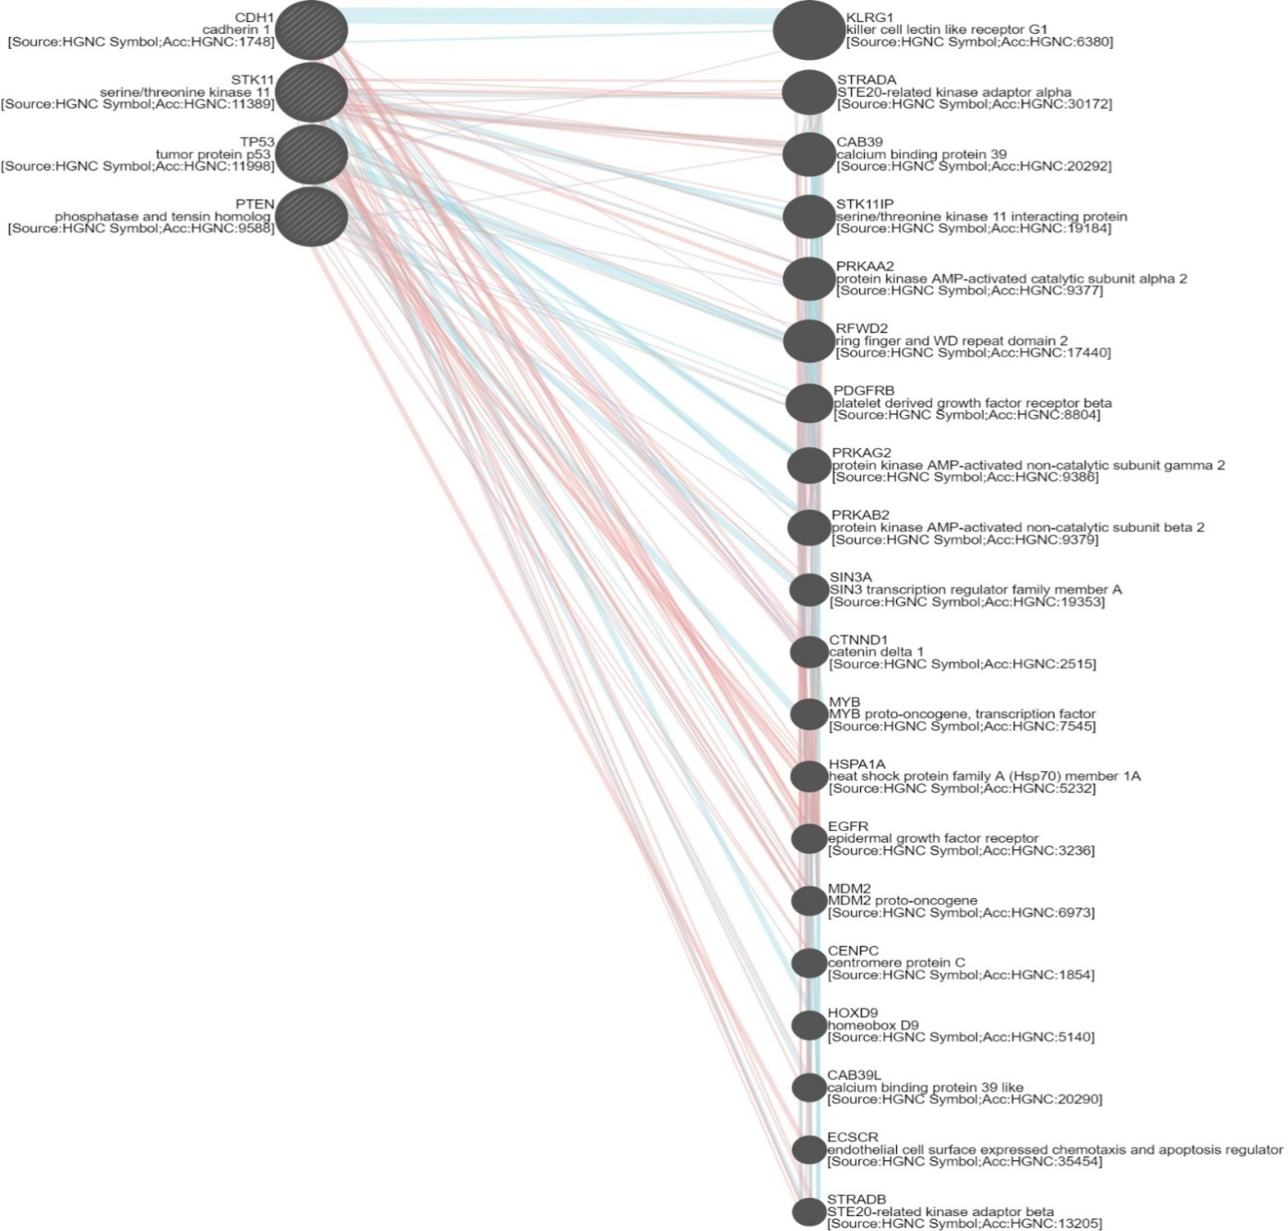

**Figure S1.1. Gene networking of Gastric and Breast Cancer genes**