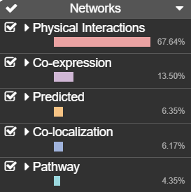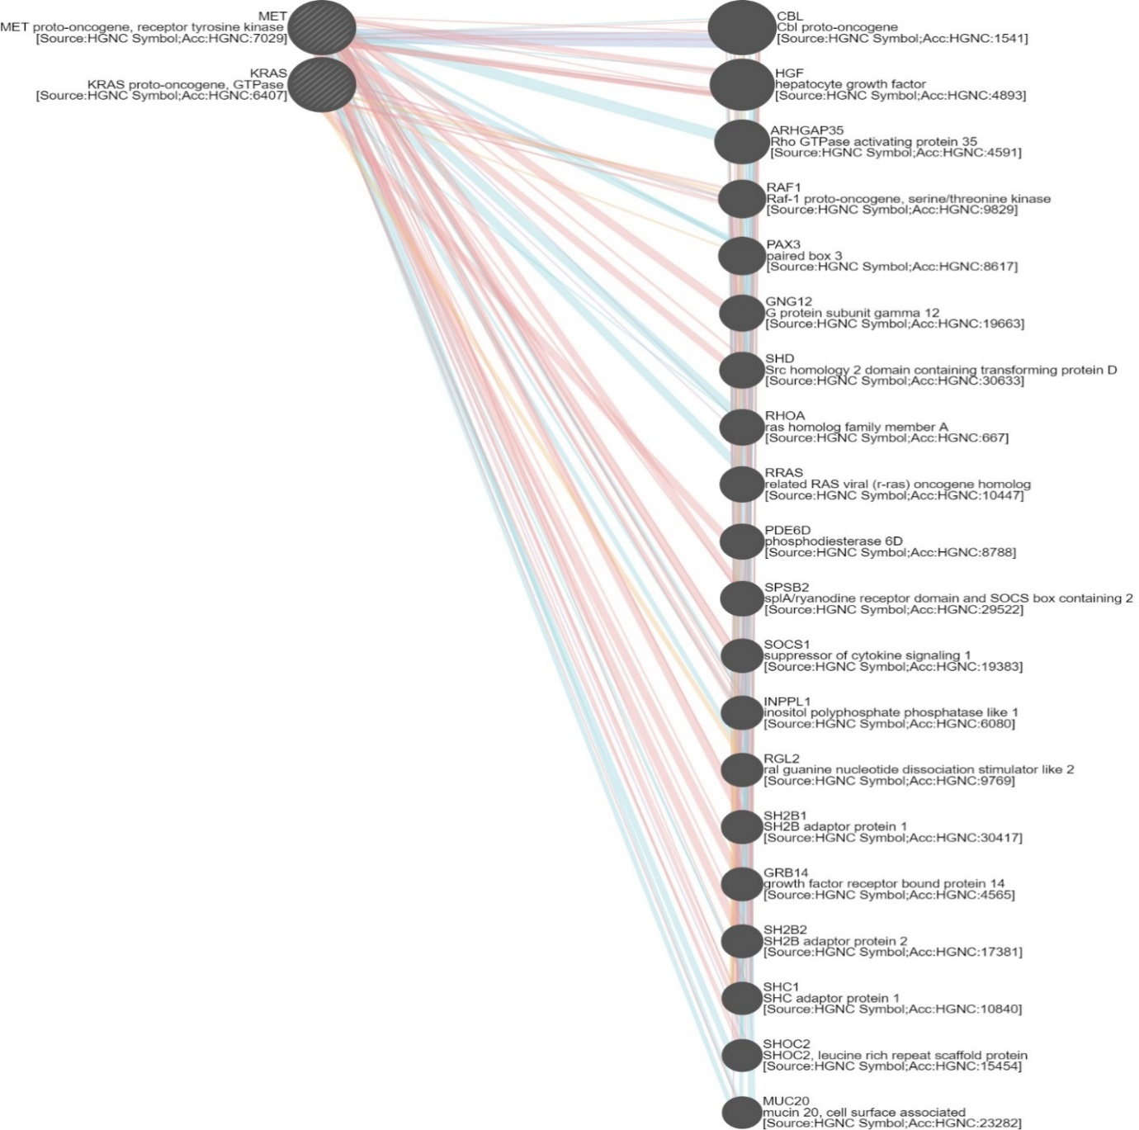

**Figure S1.3. Gene networking of Gastric and Lung Cancer genes**