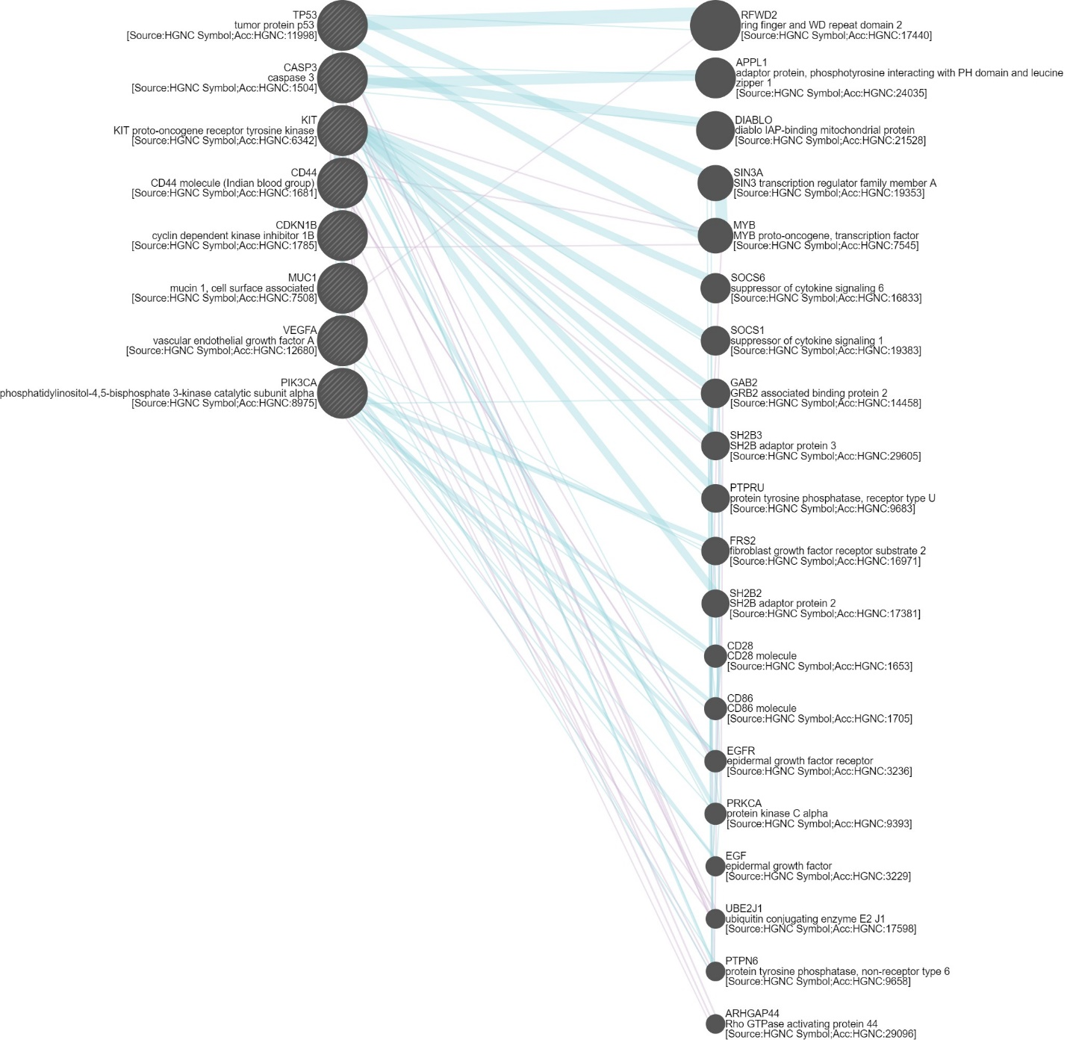

**Figure S1: Gene networking of Gastric and Bladder Cancer genes**